Algebra II
$\sqrt{Square Root}$Test Name:__________________________pd:_______

Read all directions and show work when possible

- What is the domain of the following square root function? Write in interval notation.
$y = -2\sqrt{2x-5}+7$

- What is the range of the function on question #1? Write in interval notation.

- Write a square root equation that is shifted right 3, up 3, and is vertically
compressed by $\frac{1}{5}$

- What is the starting point of $f(x) = \sqrt{x-2}+4$ ?

- Identify the inverse given the function $f(x)=\sqrt{x+6}+3$
$y^{-1}=$

- What is the domain and range of the inverse function of #5?

- Identify the inverse given the function $y=\sqrt{x+2}-4$

- Solve the following by hand $x=\sqrt{-x-4}-4$ State if one of the answers is extraneous.

- Solve the following by hand $8=3\sqrt{x-2}-4$ State if one of the answers is extraneous.

- Solve the following by hand $x+(2x+3)^{\frac{1}{2}}=0$ State if one of the answers is extraneous.

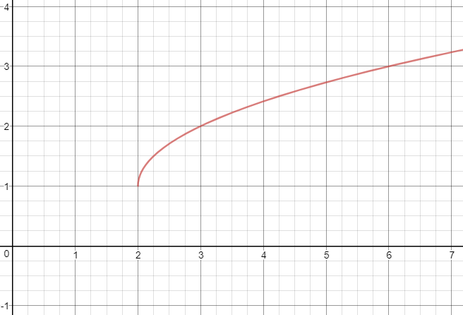
For Questions 9-11, use the following graph.

- What is the endpoint of the graph?

- What is the domain and range of the graph?
- D: $[1,∞)$ R: $[2,∞)$
- D: $[-1,∞)$ R: $[ -2,∞)$
- D: $[2,∞)$ R: $[1,∞)$
- D: $[ -2,∞)$ R: $(-∞,-1]$

13. What is the equation of the graph?
14. Solve the following by graphing
$x=$
15. Solve the following by graphing
$x=$

16. Solve the following by graphing
$x=$

17. Given the data what is the Square Root equation that best matches. Round to the nearest hundredth.

x | 2 | 5 | 7 | 10 | 12 | 15 | 18 | 20
y | 4.2 | 6.7 | 7.9 | 9.5 | 10.4 | 11.6 | 12.7 | 13.4
-

18. Inverse functions reflect over the ______________________.

19. Given the data what is the Square Root equation that best matches. Round to the nearest hundredth.

x | 30 | 43 | 59 | 97 | 145 | 172 | 202 | 234
y | 25 | 30 | 35 | 45 | 55 | 60 | 65 | 70

20. What is the domain of the INVERSE function of $f(x)=\sqrt{2x+4}$

